A1Wc Cumulative frequency curve

A cumulative frequency distribution is drawn by plotting the cumulative frequencies against their corresponding upper-class boundaries. Cumulative frequency diagrams can be used to estimate or predict other values.

Example

A group of students were asked to complete a 50-piece jigsaw. The time taken for each student to complete the jigsaw was recorded in minutes and presented in Table 1.

Time, t (minutes) | Frequency
0 < t ≤ 5 | 3
5 < t ≤ 10 | 18
10 < t ≤ 15 | 32
15 < t ≤ 20 | 26
20 < t ≤ 25 | 11
25 < t ≤ 30 | 4
Table 1

(a) Calculate the cumulative frequencies for each time
(b) Create the cumulative frequency table.
(c) Use graph paper to construct a cumulative frequency curve (also called ogive).

Use this curve to answer the questions (d) to (f):

(d) Estimate the number of students who took less than 12 minutes.
(e) Estimate how long it took for 50% of the students to complete the jigsaw.
(f) Estimate the number of students who took between 8 and 18 minutes to complete the jigsaw.

(a) Cumulative frequency table

Table 2 illustrates the procedure to calculate the cumulative frequency distribution (sometimes called an ogive) using the following relationship: each cumulative frequency = previous cumulative frequency + frequency of the current class interval.

 |  | Cumulative frequency table
Time, t (minutes) | Frequency, f | t_{CF} | Cumulative frequency, CF
 |  | ≤ 0 | 0
0 < t ≤ 5 | 3 | ≤ 5 | 3
5 < t ≤ 10 | 18 | ≤10 | 21
10 < t ≤ 15 | 32 | ≤ 15 | 53
15 < t ≤ 20 | 26 | ≤ 20 | 79
20 < t ≤ 25 | 11 | ≤ 25 | 90
25 < t ≤ 30 | 4 | ≤ 30 | 94
Table 2

(b) Cumulative frequency curve

Figure 1 illustrates the cumulative frequency curve plotted on to graph paper: (a) draw an axis with time on the horizontal axis and cumulative frequency on the vertical axis, (b) plot the paired points on the graph e.g. t = 15, CF = 53, and (c) join the paired points with a curve or a straight line (a straight line will be used here).
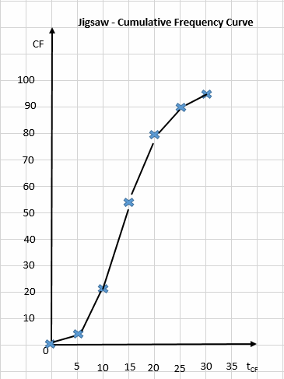
Figure 1

(c) Estimate the number of students who took less than 12 minutes.

Draw a line up to the cumulative frequency curve and then across to the vertical axis as illustrated in Figure 2. Read the value on the cumulative frequency axis.  From Figure 2, the number of students who took less than 12 minutes is 31. | 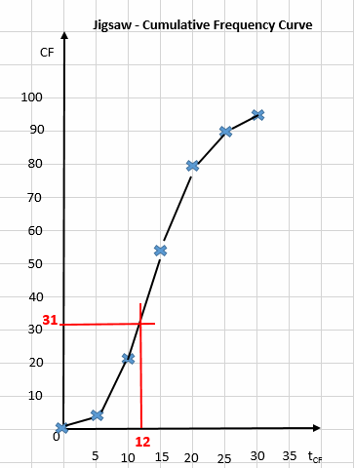  Figure 2

(d) Estimate how long it took for 50% of the students to complete the jigsaw.

We require to find 50% of the total frequency, i.e. 50% of 94 = 47. Find 47 on the cumulative frequency axis and draw a line across to the curve. Vertically drop a line from this point to the time axis.  Read the value from this axis as illustrated in Figure 3.  From Figure 3, the time for 50% of students to complete the jigsaw is 14 minutes. | 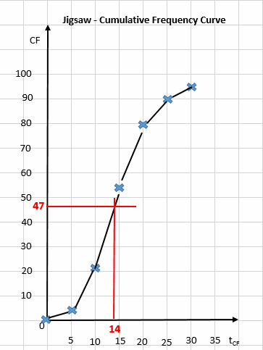  Figure 3

(e) Estimate the number of students who took between 8 and 18 minutes to complete the jigsaw.

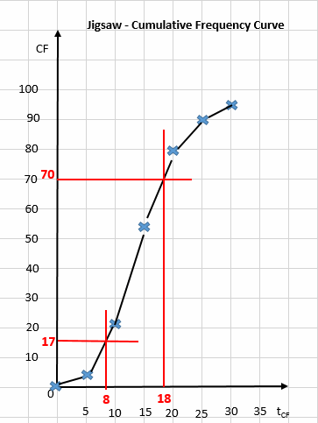
Figure 4

From Figure 4, the number of students who completed within 18 minutes is 70 and the number who completed within 8 minutes is 17. Therefore, the number of students completed between 8 and 18 minutes is 53 students (70 – 17).

Check your understanding

X1 Table 2 records the heights of boys who have registered to join the basketball club and who wish to play for one of the basketball teams.

Height, x (cms) | Frequency
110 < x ≤ 120 | 5
120 < x ≤ 130 | 12
130 < x ≤ 140 | 35
140 < x ≤ 150 | 40
150 < x ≤ 160 | 38
160 < x ≤ 170 | 20
Table 2

(a) Construct a cumulative frequency table.
(b) Use graph paper to construct a cumulative frequency diagram.
(c) Use the graph to estimate the number of boys whose height ranges between 148 cms and 152 cms.

